SOFTWARE DESIGN DOCUMENT (SDD)

Utility Billing System

1. DOCUMENT CONTROL
Item | Details
Project Name | Utility Billing System
Version | 1.0
Author | Bhavana Yeluri
Date | 29/12/2025
Status | Final

2. PURPOSE OF THE DOCUMENT
This document describes the system architecture, design decisions, component structure, APIs, data models, and non-functional aspects of the Utility Billing System.
It is intended for:
- Developers
- Reviewers
- Interview discussions
- Maintenance & enhancement planning

3. SYSTEM OVERVIEW

Business Objective
- Centralized Utility Management – Provide a single platform to manage multiple utilities, consumers, billing, and payments.
- Automated and Accurate Billing – Generate timely and error-free bills based on consumption data.
- Secure Role-Based Access – Enforce JWT-based authentication and controlled access for different user roles.
- Flexible Payment Processing – Support both online and offline payment methods for user convenience.
- Real-Time Notifications and Transparency – Notify users about bills, payments, and reminders to improve transparency.
- Scalable and Fault-Tolerant Architecture – Use microservices, centralized configuration, and resilience mechanisms to ensure scalability and availability.

4. ARCHITECTURE OVERVIEW (HLD)

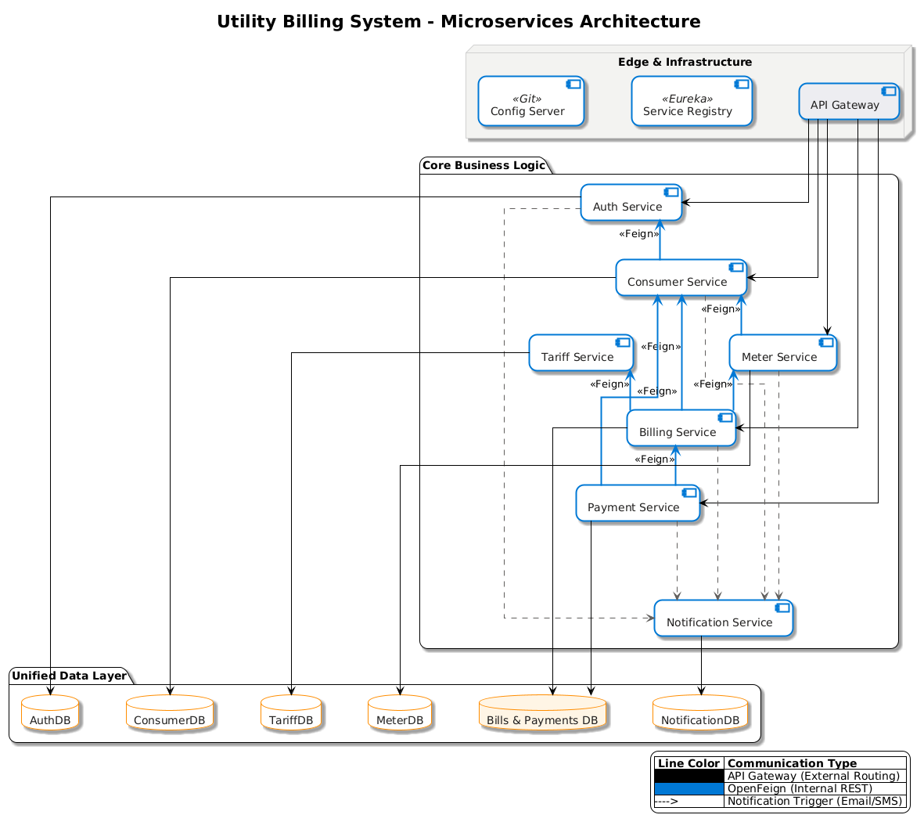

Architecture Style
- Microservices Architecture
- REST-based communication
- Containerized deployment

Core Components
- API Gateway – Acts as the single entry point, handling request routing, JWT validation, and role-based access control.
- Service Registry (Eureka Server) – Enables dynamic service discovery and load balancing among microservices.
- Config Server – Provides centralized, version-controlled configuration management for all microservices.
- Auth Service – Manages user authentication, authorization, and JWT token generation.
- Consumer Service – Handles consumer onboarding, approval workflows, and consumer profile management.
- Meter Service – Manages utility connection requests, meter assignment, and meter readings.
- Tariff Service – Maintains tariff plans, slabs, taxes, and penalty configurations for utilities.
- Billing Service – Generates utility bills based on meter readings, tariff rules, and consumption data.
- Payment Service – Processes online and offline payments, verifies transactions, and generates invoices.
- Notification Service – Sends system notifications such as emails and OTPs for approvals, payments, and alerts.
- Databases – Maintains isolated MongoDB databases per service for scalability and data independence.
- Resilience and Fault Tolerance Layer – Prevents cascading failures and ensures system stability.

5. TECHNOLOGY STACK

Backend
- Java 17
- Spring Boot
- Spring Web
- Spring Data MongoDB
- Spring Validation
- Open Feign
- Resilience 4j (Circuit Breaker)

Frontend
- Angular
Database
- MongoDB (one DB per microservice)

DevOps
- Docker
- Docker Compose
- Jenkins
- SonarQube

Testing
- JUnit 5
- Mockito
- Spring Boot Test

6. MICROSERVICES DESIGN

6.1 Auth Service
Responsibilities
- User registration and login
- JWT token generation and validation
- Role-based access control
- Forgot password and reset password flows
APIs
POST /auth/register
Request Payload
{
"username":"john_doe",
"email":"john.doe@gmail.com",
"password":"Password@123",
"role":"CONSUMER"
}

Response Payload
{
"userId":"U101",
"message":"User registered successfully"
}

POST /auth/login
Request Payload
{
"username": "string",
"password": "stringst"
}
Response Payload
{
"token": "string"
}

POST /auth/forgot-password
Request Payload
{
"email":"john.doe@gmail.com"
}
Response Payload
{
"message":"Password reset link sent to registered email"
}

POST /auth/reset-password
Request Payload
{
"resetToken":"reset-token-xyz",
"newPassword":"NewPassword@123"
}
Response Payload
{
"message":"Password reset successful"
}

PUT /auth/change-password
Request Payload
{
"oldPassword":"Password@123",
"newPassword":"UpdatedPassword@123"
}
Response Payload
{
"message":"Password updated successfully"
}

GET /auth/users
Response Payload
[
{
"userId":"U101",
"username":"john_doe",
"email":"john.doe@gmail.com",
"role":"CONSUMER",
"status":"ACTIVE"
}
]

GET /auth/users/{userId}
Response Payload
{
"userId":"U101",
"username":"john_doe",
"email":"john.doe@gmail.com",
"role":"CONSUMER",
"status":"ACTIVE"
}

DELETE /auth/users/{userId}
Response Payload
{
"message":"User deleted successfully"
}
Database
- users collection
- password_reset_tokens collection

6.2 Consumer Service

Responsibilities
- Consumer registration and profile management
- Linking consumers to utility connections
- Managing connection status
APIs
POST /consumers
Request Payload
{
"name":"Alice Johnson",
"phone":"9876543210",
"email":"alice@gmail.com",
"address":"Hyderabad"
}
Response Payload
{
"consumerId":"C201",
"message":"Consumer registered successfully"
}

GET /consumers/{consumerId}
Response Payload
{
"consumerId":"C201",
"name":"Alice Johnson",
"phone":"9876543210",
"email":"alice@gmail.com",
"address":"Hyderabad",
"status":"ACTIVE"
}

GET /consumers
Response Payload
[
{
"consumerId":"C201",
"name":"Alice Johnson",
"status":"ACTIVE"
}
]

PUT /consumers/{consumerId}
Request Payload
{
"phone":"9999999999",
"address":"Bangalore"
}
Response Payload
{
"message":"Consumer updated successfully"
}

DELETE /consumers/{consumerId}
Response Payload
{
"message":"Consumer deactivated successfully"
}

POST /connections
Request Payload
{
"consumerId":"C201",
"utilityId":"U1",
"meterNumber":"MTR1001",
"tariffId":"T101"
}
Response Payload
{
"connectionId":"CN301",
"status":"ACTIVE"
}

GET /connections/{consumerId}
Response Payload
[
{
"connectionId":"CN301",
"utilityId":"U1",
"meterNumber":"MTR1001",
"status":"ACTIVE"
}
]

PUT /connections/{connectionId}
Request Payload
{
"status":"DISCONNECTED"
}
Response Payload
{
"message":"Connection status updated"
}
Database
- consumers collection
- connections collection

6.3 Utility Service
Responsibilities
- Manage utility types (Electricity, Water, Gas, etc.)
- Define billing units and billing cycles
- Manage tariff slabs, taxes, and fixed charges
APIs
POST /utilities
Request Payload
{
"name":"ELECTRICITY",
"unit":"kWh",
"billingCycle":"MONTHLY"
}
Response Payload
{
"utilityId":"U1",
"message":"Utility created successfully"
}

GET /utilities
Response Payload
[
{
"utilityId":"U1",
"name":"ELECTRICITY",
"unit":"kWh",
"billingCycle":"MONTHLY"
}
]

GET /utilities/{utilityId}
Response Payload
{
"utilityId":"U1",
"name":"ELECTRICITY",
"unit":"kWh",
"billingCycle":"MONTHLY"
}

PUT /utilities/{utilityId}
Request Payload
{
"unit":"Units",
"billingCycle":"MONTHLY"
}
Response Payload
{
"message":"Utility updated successfully"
}

POST /tariffs
Request Payload
{
"utilityId":"U1",
"slabs":[
{"min":0,"max":100,"rate":3.5},
{"min":101,"max":300,"rate":5.0}
],
"fixedCharge":120,
"taxPercent":5
}
Response Payload
{
"tariffId":"T101",
"message":"Tariff created successfully"
}

GET /tariffs
Response Payload
[
{
"tariffId":"T101",
"utilityId":"U1",
"fixedCharge":120,
"taxPercent":5
}
]

GET /tariffs/{tariffId}
Response Payload
{
"tariffId":"T101",
"utilityId":"U1",
"slabs":[
{"min":0,"max":100,"rate":3.5},
{"min":101,"max":300,"rate":5.0}
]
}

GET /tariffs/utility/{utilityId}
Response Payload
{
"tariffId":"T101",
"utilityId":"U1",
"fixedCharge":120,
"taxPercent":5
}

PUT /tariffs/{tariffId}
Request Payload
{
"fixedCharge":150,
"taxPercent":6
}
Response Payload
{
"message":"Tariff updated successfully"
}
Database
- utilities collection
- tarrif_plans collection

6.4 Meter Service
Responsibilities
- Record monthly meter readings
- Validate readings against previous values
- Calculate units consumed per billing cycle
APIs
POST /meter-readings
Request Payload
{
"consumerId":"C201",
"utilityId":"U1",
"previousReading":330,
"currentReading":450,
"readingDate":"2025-03-01"
}
Response Payload
{
"meterReadingId":"MR401",
"unitsConsumed":120,
"message":"Meter reading recorded successfully"
}

GET /meter-readings/{consumerId}
Response Payload
[
{
"meterReadingId":"MR401",
"utilityId":"U1",
"previousReading":330,
"currentReading":450,
"unitsConsumed":120,
"readingDate":"2025-03-01"
}
]

GET /meter-readings/latest/{consumerId}
Response Payload
{
"meterReadingId":"MR401",
"utilityId":"U1",
"currentReading":450,
"unitsConsumed":120,
"readingDate":"2025-03-01"
}

Database
- meter_readings collection

6.5 Billing Service
Responsibilities
- Generate bills based on meter readings and tariffs
- Apply fixed charges and taxes
- Maintain bill status transitions
APIs
POST /bills/generate
Request Payload
{
"consumerId":"C201",
"utilityId":"U1",
"billingMonth":"MARCH",
"billingYear":2025
}
Response Payload
{
"billId":"B501",
"totalUnits":120,
"energyCharge":950,
"fixedCharge":120,
"taxAmount":45,
"totalAmount":1115,
"status":"GENERATED"
}

GET /bills/{billId}
Response Payload
{
"billId":"B501",
"consumerId":"C201",
"utilityId":"U1",
"billingPeriod":"MARCH-2025",
"totalAmount":1115,
"status":"DUE"
}

GET /bills/consumer/{consumerId}
Response Payload
[
{
"billId":"B501",
"billingPeriod":"MARCH-2025",
"totalAmount":1115,
"status":"DUE"
}
]

GET /bills
Response Payload
[
{
"billId":"B501",
"consumerId":"C201",
"totalAmount":1115,
"status":"DUE"
}
]

PUT /bills/{billId}/status
Request Payload
{
"status":"DUE"
}
Response Payload
{
"message":"Bill marked as PAID"
}
Database
- bills collection

6.6 Notification Service
Responsibilities
- Send bill generation notifications
- Send payment reminders
- Send password reset notifications
APIs
POST /notifications/bill-generated
Request Payload
{
"consumerId":"C201",
"billId":"B501",
"message":"Your electricity bill for March 2025 has been generated."
}
Response Payload
{
"notificationId":"N601",
"status":"SENT"
}

POST /notifications/payment-reminder
Request Payload
{
"consumerId":"C201",
"billId":"B501",
"dueDate":"2025-03-15"
}
Response Payload
{
"notificationId":"N602",
"status":"SENT"
}

POST /notifications/password-reset
Request Payload
{
"email":"john.doe@gmail.com",
"resetLink":"https://app/reset-password?token=abc123"
}
Response Payload
{
"email":"john.doe@gmail.com",
"resetLink":"https://app/reset-password?token=abc123"
}

GET /notifications/{consumerId}
Response Payload
[
{
"notificationId":"N601",
"type":"BILL_GENERATED",
"message":"Your electricity bill has been generated.",
"status":"SENT"
}
]
Database
- notifications collection

7. DATA DESIGN (LLD)

User DB

User Document

{

"_id": ObjectId,

"username": "string",

"email": "string",

"password": "string (encrypted)",

"roles": ["ADMIN | USER | ACCOUNTS_OFFICER | BILLING_OFFICER"],

"enabled": true,

"passwordUpdatedAt": ISODate,

"createdAt": ISODate

}

Consumers DB

Consumer Document

{

"_id": ObjectId,

"fullName": "string",

"email": "string",

"phone": "string",

"addressLine1": "string",

"city": "string",

"state": "string",

"postalCode": "string",

"active": true,

"createdAt": ISODate,

"updatedAt": ISODate

}

Consumer Request Document

{

"_id": ObjectId,

"fullName": "string",

"email": "string",

"phone": "string",

"addressLine1": "string",

"city": "string",

"state": "string",

"postalCode": "string",

"status": "PENDING | APPROVED | REJECTED",

"createdAt": ISODate,

"updatedAt": ISODate

}

Meter DB

Connection Request Document

{

"_id": ObjectId,

"consumerId": "ObjectId",

"utilityType": "ELECTRICITY | GAS | WATER",

"tariffPlan": "DOMESTIC | COMMERCIAL",

"status": "PENDING | APPROVED | REJECTED",

"createdAt": ISODate

}

Meter Document

{

"_id": ObjectId,

"meterNumber": "string",

"consumerId": "ObjectId",

"utilityType": "ELECTRICITY | GAS | WATER",

"tariffPlan": "DOMESTIC | COMMERCIAL",

"lastReading": "number",

"installationDate": ISODate,

"active": true

}

Meter Reading Document

{

"_id": ObjectId,

"meterNumber": "string",

"readingValue": "number",

"readingDate": ISODate

}

Tariff DB

Tariff Document

{

"_id": ObjectId,

"utilityType": "ELECTRICITY | GAS | WATER",

"plans": [

{

"plan": "DOMESTIC | COMMERCIAL",

"active": true,

"fixedCharge": "number",

"taxPercentage": "number",

"slabs": [

{

"fromUnit": "number",

"toUnit": "number",

"ratePerUnit": "number"

}

],

"overduePenaltySlabs": [

{

"fromDay": "number",

"toDay": "number",

"penaltyPercentage": "number"

}

]

}

],

"effectiveFrom": ISODate

}

Bills & Payments DB

Bill Document

{

"_id": ObjectId,

"consumerId": "ObjectId",

"meterNumber": "string",

"utilityType": "ELECTRICITY | GAS | WATER",

"tariffPlan": "DOMESTIC | COMMERCIAL",

"previousReading": "number",

"currentReading": "number",

"unitsConsumed": "number",

"energyCharge": "number",

"fixedCharge": "number",

"taxAmount": "number",

"penaltyAmount": "number",

"totalAmount": "number",

"status": "DUE | PAID | OVERDUE",

"generatedAt": ISODate,

"dueDate": ISODate,

"lastUpdatedAt": ISODate

}

Payment Document

{

"_id": ObjectId,

"billId": "ObjectId",

"consumerId": "ObjectId",

"utilityType": "ELECTRICITY | GAS | WATER",

"amount": "number",

"mode": "ONLINE | OFFLINE",

"status": "INITIATED | SUCCESS | FAILED",

"processedBy": "SYSTEM | ACCOUNTS_OFFICER",

"initiatedAt": ISODate,

"completedAt": ISODate

}

Invoice Document

{

"_id": ObjectId,

"paymentId": "ObjectId",

"consumerId": "ObjectId",

"meterNumber": "string",

"utilityType": "ELECTRICITY | GAS | WATER",

"previousReading": "number",

"currentReading": "number",

"unitsConsumed": "number",

"energyCharge": "number",

"fixedCharge": "number",

"taxAmount": "number",

"penaltyAmount": "number",

"totalAmount": "number",

"paymentMode": "ONLINE | OFFLINE",

"paymentDate": ISODate,

"billGeneratedAt": ISODate,

"billDueDate": ISODate,

"invoiceGeneratedAt": ISODate

}

Notification DB
Notification document
{
"_id": ObjectId,
"recipient": "string (email)",
"type": "PASSWORD_RESET | CONSUMER_APPROVED | CONNECTION_APPROVED | BILL_GENERATED | PAYMENT_OTP | PAYMENT_SUCCESS | PAYMENT_FAILED | INVOICE_PDF",
"channel": "EMAIL",
"status": "SENT | FAILED",
"subject": "string",
"body": "string",
"createdAt": ISODate
}

8. API DESIGN & VALIDATION
- RESTful principles
- JSON request/response
- Bean Validation at DTO layer
- Service-level business rule enforcement
- Standard HTTP status codes

9. ERROR HANDLING STRATEGY

Global Exception Handling
- Centralized using @ControllerAdvice
- Standard error response format
{
"timestamp": "2025-01-01T10:00:00",
"status": 400,
"error": "Validation Error",
"message": "Price must be greater than zero"
}

10. SECURITY DESIGN
- Password encryption (BCrypt)
- Role-based access control
- JWT authentication (optional enhancement)
- Secure API access

11. Business Rules
1. Authentication & Authorization Service
- Users must authenticate using valid credentials.
- JWT tokens are issued after successful authentication.
- Tokens contain user identity and role information.
- Role-based access control is enforced across all services.
- Only active users are allowed to access the system.
- Password reset tokens are single-use and time-bound.

2. Consumer Service
- Each consumer must be linked to a valid authenticated user.
- A consumer can have multiple utility connections.
- Consumer profile data can be modified only by authorized users.
- Consumer records are soft-deleted to preserve historical data.
- A consumer request must be approved before any utility connection can be requested.
- Rejected consumer requests cannot be reused and must be re-submitted.

3. Utility Connection Service
- Each utility connection must have a defined utility type and tariff plan.
- A connection belongs to exactly one consumer.
- Tariff changes do not affect previously generated bills.
- A consumer cannot have more than one active connection of the same utility type.

4. Meter Reading Service
- Meter readings can be recorded only for active connections.
- New readings must not be less than previous readings.
- Only authorized role(billing officer) can submit meter readings.
- Meter readings are immutable once recorded.

5. Billing Service
- Bills are generated based on meter readings and tariff plans.
- Each bill has a defined lifecycle: Due, Paid, or Overdue.
- Bills marked as paid cannot be modified.
- Overdue status is determined based on due date.
- Penalty calculation applies only after due date is crossed.

6. Payment Service
- Online payments require OTP verification.
- Payment is confirmed only after successful OTP validation.
- Offline payments can be recorded only by authorized staff(accounts officer).
- A bill is marked as paid only after successful payment confirmation.
- Each successful payment generates an invoice.

7. Notification Service
- Notifications are sent for bill generation and payment events.
- Notification failures do not impact core business flow.
- Each notification is associated with a specific user and event.

8. Dashboard & Reporting Service
- Dashboard data is read-only and aggregated from multiple services.
- Financial reports are accessible only to authorized roles.
- Reports reflect consistent and finalized transactional data.

9. System-Wide Rules
- All inter-service communication is secured using JWT.
- Services are loosely coupled and independently deployable.
- Circuit breakers handle service failures gracefully.

11. NON-FUNCTIONAL REQUIREMENTS
Area | Design Decision
Scalability | Stateless services, Docker
Performance | Pagination, async calls
Availability | Independent services
Maintainability | POM-like layered backend
Security | Validation, encryption
Observability | Logging & monitoring

12. TESTING STRATEGY
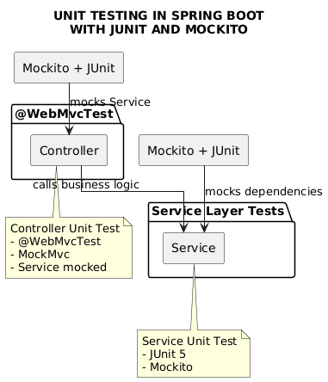

Backend
- Unit tests (Service layer)
- Controller tests
- 95.9% coverage

Quality Gates
- SonarQube enforced
- Build fails on violations
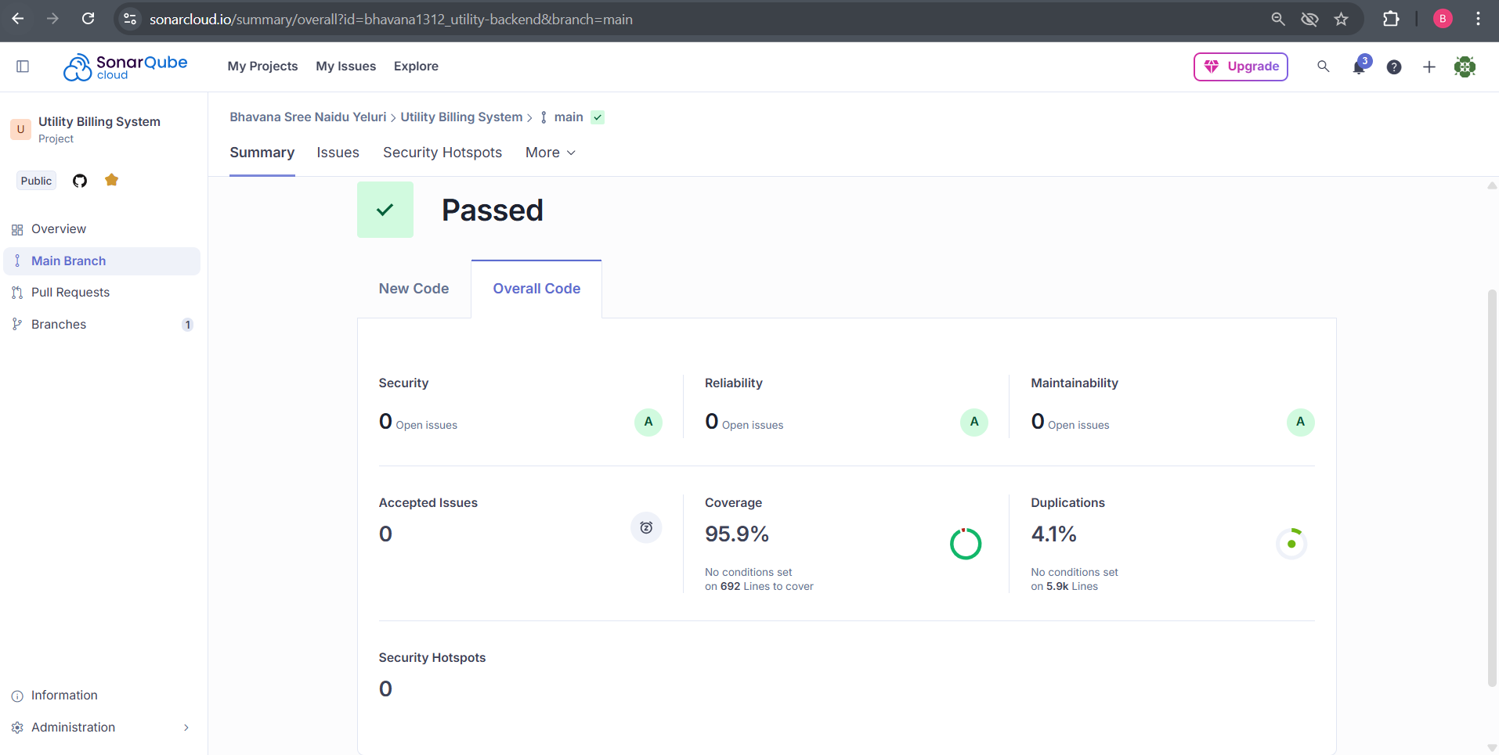

13. CI/CD DESIGN

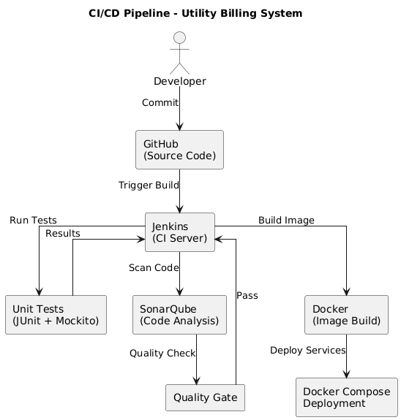

Pipeline Flow
- Git Commit
- Jenkins Build
- Unit Tests
- SonarQube Scan
- Quality Gate Check
- Docker Build
- Docker Compose Deploy

14. DEPLOYMENT DESIGN
- Docker image per microservice
- docker-compose for orchestration
- Environment-specific configs

15. ASSUMPTIONS & CONSTRAINTS

Assumptions
- Services communicate over REST
- MongoDB available
- Docker environment present

Constraints
- No distributed transactions
- Event-driven architecture out of scope

16. FUTURE ENHANCEMENTS
- Kubernetes deployment
- Centralized logging (ELK)

17. CONCLUSION
This design ensures:
✔ Clean separation of concerns
✔ Scalability & maintainability
✔ Testability & CI/CD readiness
✔ Interview-ready explanation

SEQUENCE DIAGRAMS
UTILITY BILLING SYSTEM
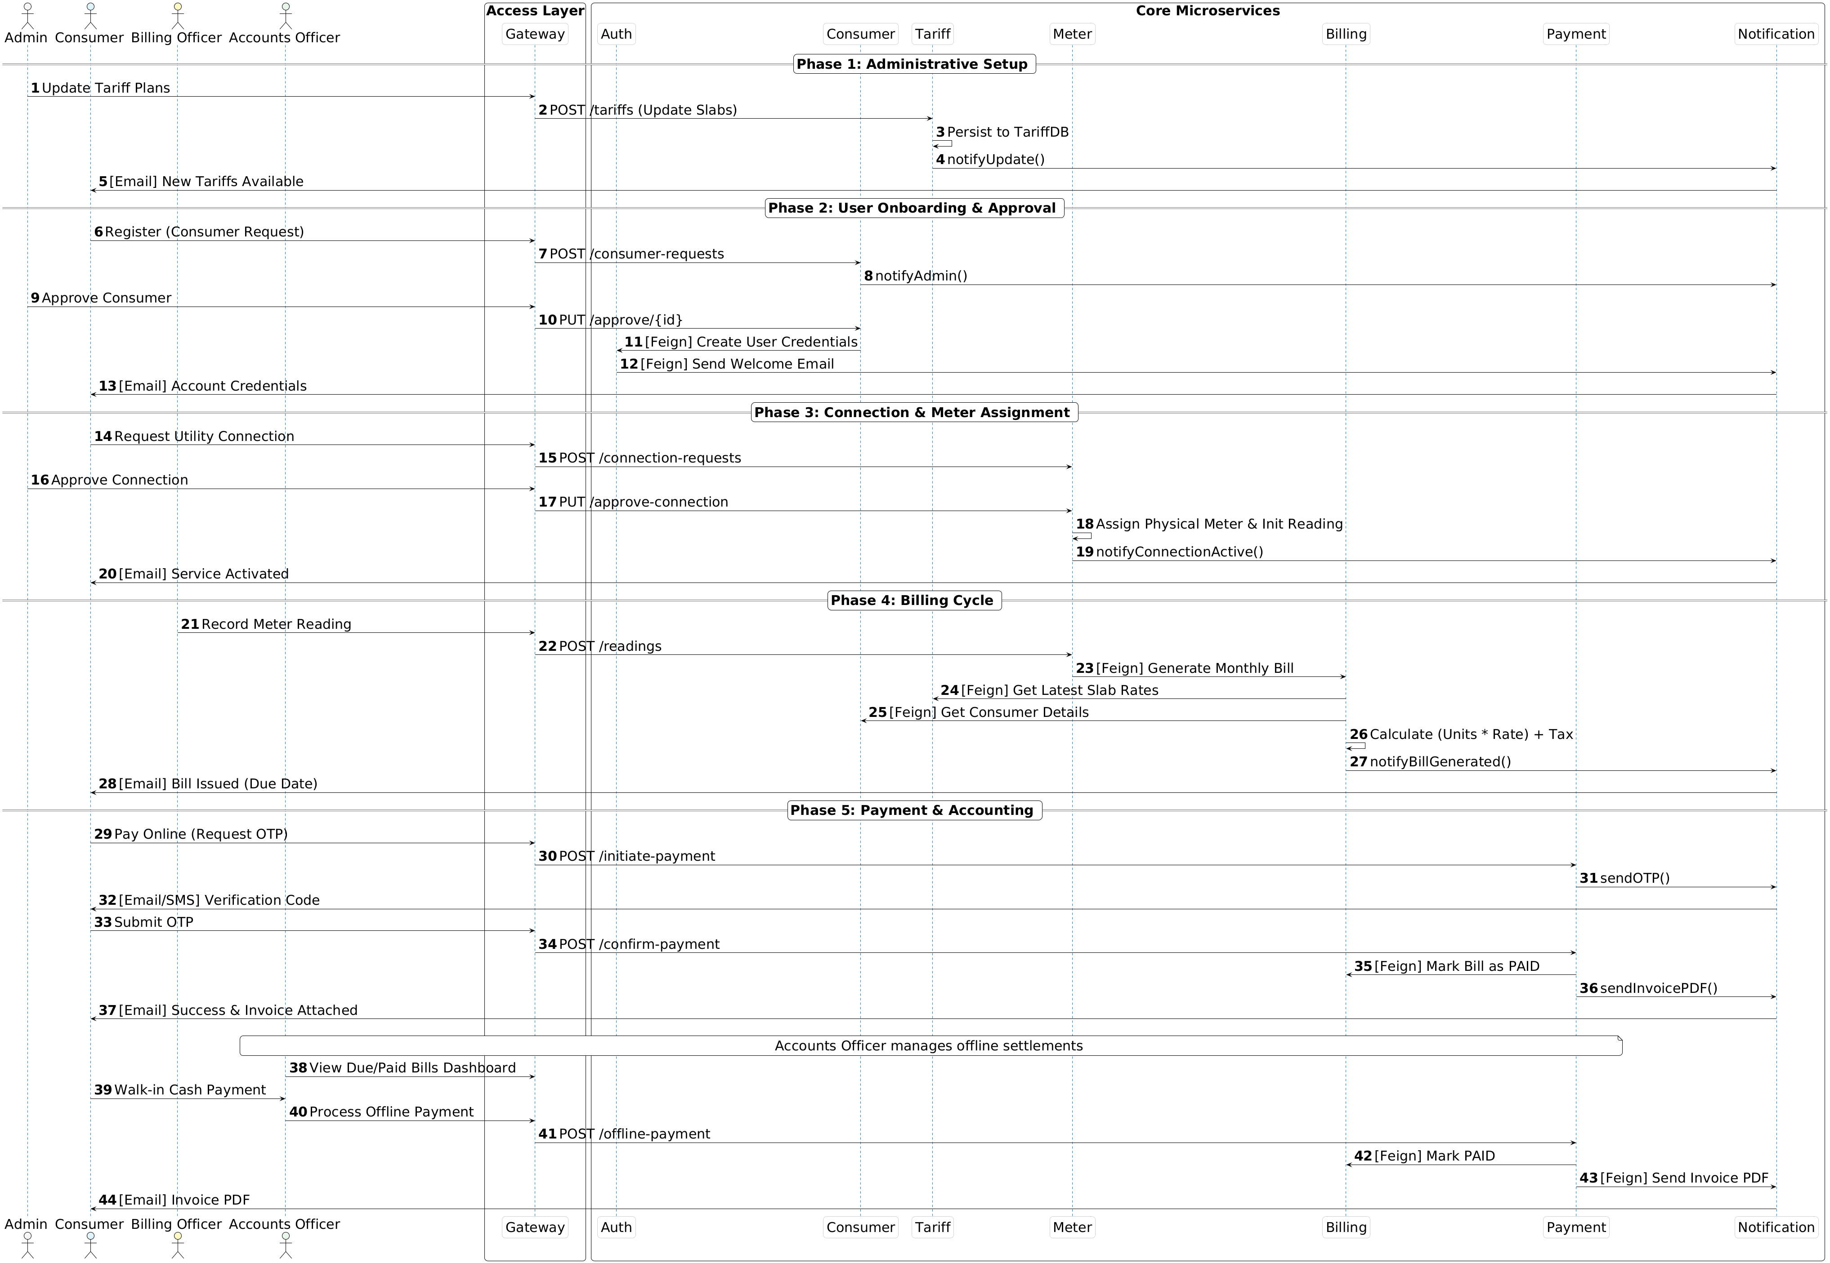

1. User Registration — Sequence Diagram

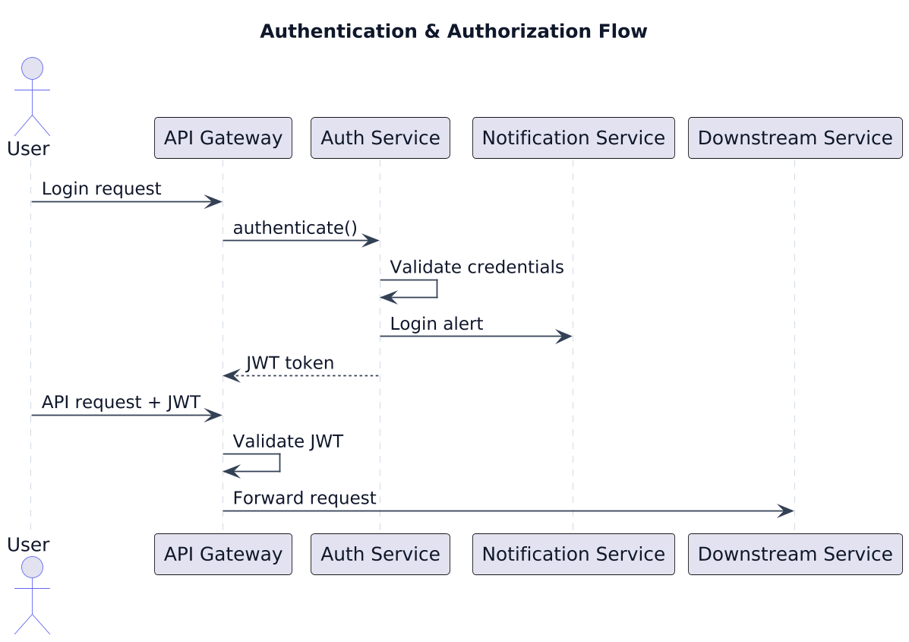

Scenario

A user authenticates using valid credentials, receives a JWT token, and accesses secured backend services through the API Gateway.

Flow
- The user submits login credentials to the API Gateway.
- The API Gateway forwards the authentication request to the Auth Service.
- The Auth Service validates the user credentials against stored user data.
- Upon successful authentication, the Auth Service generates a JWT token.
- A login notification is sent via the Notification Service.
- The JWT token is returned to the user through the API Gateway.
- For subsequent requests, the user sends the JWT token along with the API request.
- The API Gateway validates the JWT token and extracts user role information.
- If valid, the request is forwarded to the appropriate downstream service.

Participants
- User
- API Gateway
- Auth Service
- Notification Service
- Downstream Service

2. Administrative Setup— Sequence Diagram
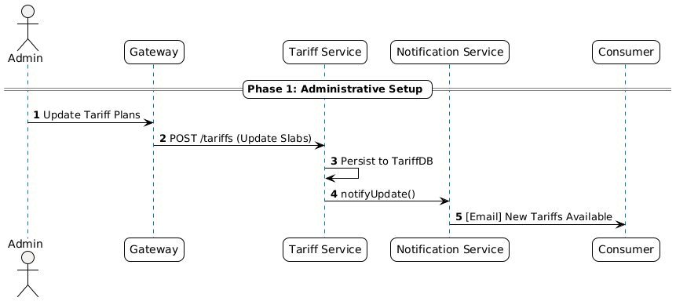

Scenario

The administrator configures or updates tariff plans, which are stored centrally and communicated to consumers.

Flow
- Admin updates tariff plans through the Gateway.
- Gateway forwards the request to the Tariff Service.
- Tariff Service saves the updated tariff configuration.
- Notification Service informs consumers about tariff updates.

Participants
- Admin
- API Gateway
- Tariff Service
- Notification Service
- Consumer

3. User Onboarding & Approval — Sequence Diagram

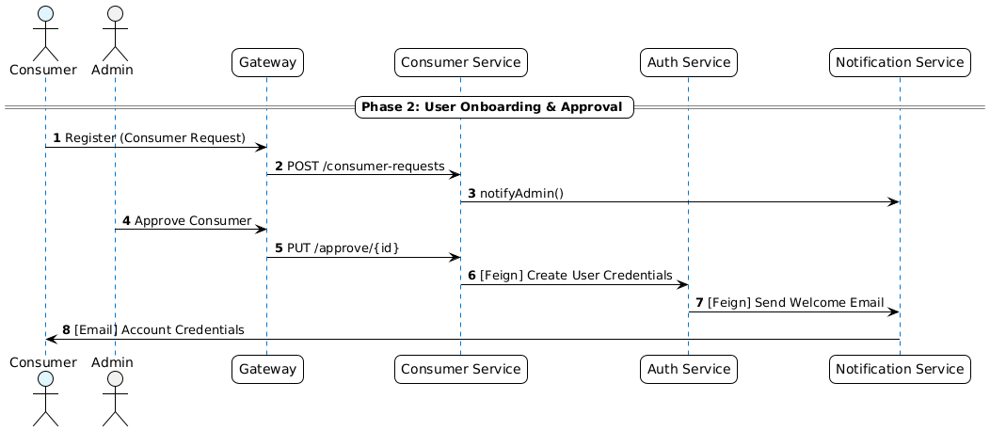

Scenario

A consumer registers in the system and gets approved by the administrator to gain portal access.

Flow
- Consumer submits a registration request through the Gateway.
- Consumer Service creates a consumer request.
- Admin approves the consumer request.
- Auth Service creates login credentials.
- Credentials are sent to the consumer via email.

Participants
- Consumer
- Admin
- API Gateway
- Consumer Service
- Auth Service
- Notification Service

4. Connection & Meter Assignment — Sequence Diagram
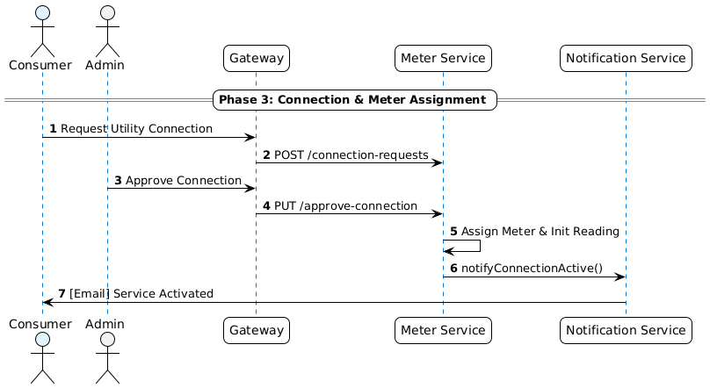

Scenario

An approved consumer requests a utility connection, which is validated and assigned a meter by the administrator.

Flow
- Consumer requests a utility connection.
- Meter Service records the connection request.
- Admin approves the connection request.
- A meter is assigned and initialized.
- Consumer is notified about service activation.

Participants
- Consumer
- Admin
- API Gateway
- Meter Service
- Notification Service

5. Billing Cycle — Sequence Diagram
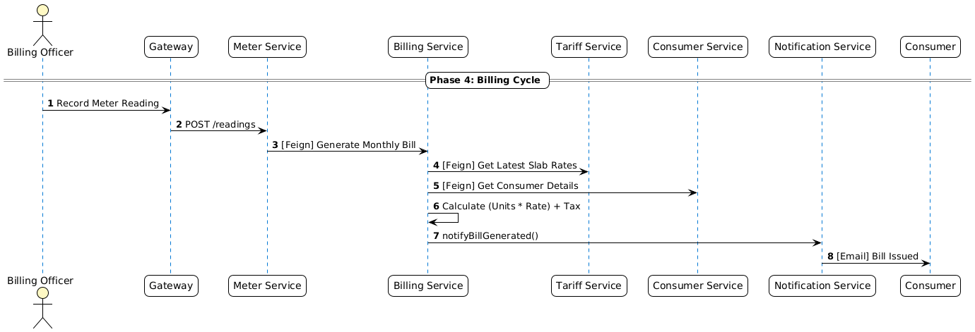

Scenario

Periodic meter readings are recorded and used to generate utility bills for consumers.

Flow
- Billing Officer records meter readings.
- Meter Service validates and forwards data for billing.
- Billing Service retrieves tariff and consumer details.
- Bill amount is calculated based on consumption and slabs.
- Bill is generated and notified to the consumer.

Participants
- Billing Officer
- API Gateway
- Meter Service
- Billing Service
- Tariff Service
- Consumer Service
- Notification Service

- Payment & Accounting — Sequence Diagram

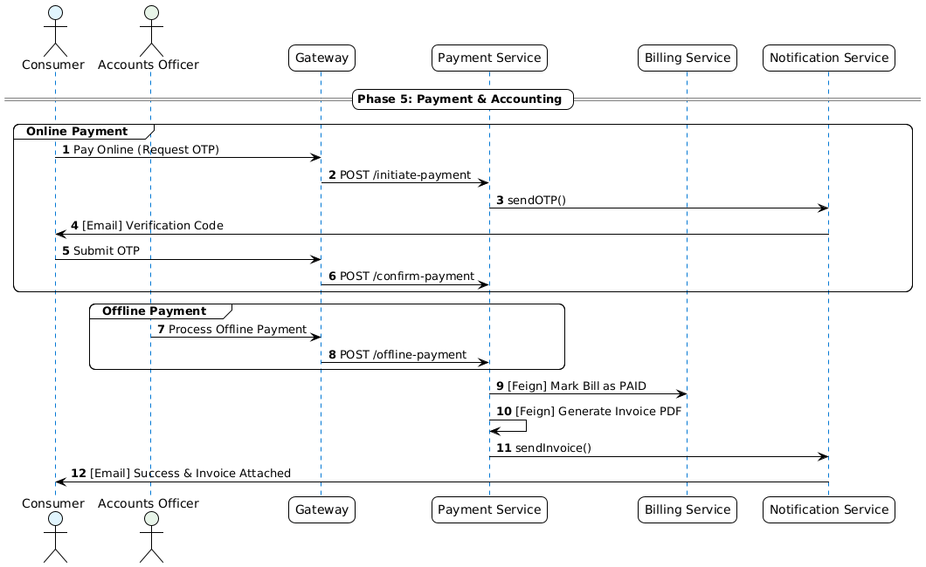

Scenario

Consumers settle bills through online or offline payment methods, and invoices are generated.

Flow
- Consumer initiates online payment and requests OTP.
- OTP is sent and verified before confirmation.
- Accounts Officer can record offline payments.
- Payment Service marks the bill as paid.
- Invoice is generated and emailed to the consumer.

Participants
- Consumer
- Accounts Officer
- API Gateway
- Payment Service
- Billing Service
- Notification Service

- CI/CD — Sequence Diagram

Scenario
Developer pushes code to Git repository.

Flow
- Developer pushes code
- Jenkins pipeline triggered
- Jenkins runs unit tests
- Jenkins runs SonarQube scan
- Quality gate checked
- Docker images built
- Docker Compose deploys services

Participants
- Developer
- Git
- Jenkins
- SonarQube
- Docker

7. Error Handling — Sequence Diagram

Scenario
Invalid request sent to backend.

Flow
- Angular sends invalid request
- Controller validation fails
- Global exception handler triggered
- Standard error response returned

Key Point
- Consistent error structure across services

